|  |  |  |  |
| --- | --- | --- | --- |
| **F:\Learning bugs\Foundation Subjects\Dolly the Fly - Science.jpgLyng Primary School Knowledge Organiser** | | | |
| **Topic: Science** | **Use of Everyday Materials**  What are materials and when should they be used? | Year 2 | Spring Term |

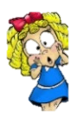

|  |  |
| --- | --- |
| **What Goldilocks and Step On words will I use?** | |
| **Spelling** | **Definition** |
| Absorbent | Can soak up liquid easily. |
| Bend | Changing a straight object so that it is curved. |
| Change | How materials can differ. |
| Compare | To look at two or more materials and state what is the same and different. |
| Flexible | Bending without breaking |
| Group | Materials can be placed in groups based on their properties eg. wood, metal, glass etc. |
| Manufactured | When a raw material is made into a new one eg. wood into paper. |
| Material | A substance that has a name. |
| Natural | When a material is used in its raw state eg. wooden door. |
| Shape | The way a material looks |
| Solid | A material that cannot change shape |
| Squash | Crush something so that it becomes flat, soft, or out of shape. |
| Stretch | Make longer or wider without tearing or breaking. |
| Suitability | How effective a material is for a task. |
| Twist | Change the shape of an object by turning it. |

**What should I already know?**

* Materials are the substances that things are made from.
* We use lots of different materials every day, eg. metal, plastic, wood and glass.
* Different materials have certain properties, eg. glass is see-through, metal is strong and often shiny.
* Objects feel and look different based on the material they are made from.
* Some materials are used to make many things.

**Notable Scientist:**

**Charles Macintosh** – Scottish inventor who invented waterproof fabrics like the Mackintosh raincoat in 1824.

|  |
| --- |
| **Key questions - sequence of learning** |
| * What materials are the different objects made from and why? * What properties do different objects have and why? * How can you make an object change shape? * How could we find out which material is stretchiest? * How could you test the strength of different paper folds * What are eco-friendly materials?   We will conduct an investigation to find out:  **What paper fold will be the strongest?** |

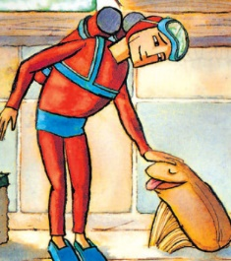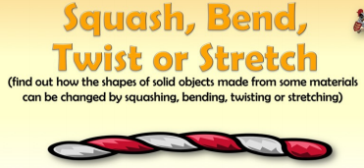

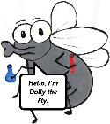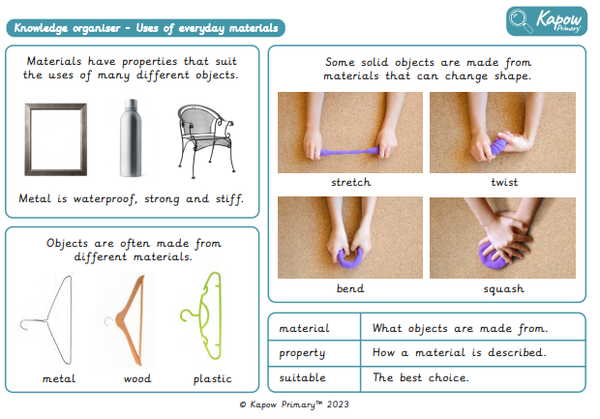

**What will I know by the end of the unit?**

|  |  |
| --- | --- |
|  | |
| Which materials some objects are made from. |  |
| What words I can use to describe materials |  |
| The difference between Natural and Man-made materials | **Natural Materials:** are those which are found in nature. **Man-made Materials: those** that are changed by people or machines. |

|  |  |  |  |
| --- | --- | --- | --- |
| **F:\Learning bugs\Foundation Subjects\Dolly the Fly - Science.jpgLyng Primary School Knowledge Organiser** | | | |
| **Topic:** | **Science** | Year 2  Materials | Spring Term |

|  |  |  |  |
| --- | --- | --- | --- |
| 1. Paper towels are good for spillages because… | **S** | | **E** |
| they are stretchy |  |  | |
| they are absorbent |  |  | |
| they are heavy |  |  | |
| they are lightweight |  |  | |

|  |  |  |
| --- | --- | --- |
|  | **S** | **E** |
| 5. Name two items made from plastic | 1.  2. | 1.  2. |

|  |  |  |
| --- | --- | --- |
| 6. Which items are stretchy?  **Tick two** | **S** | **E** |
| Elastic bands |  |  |
| Sponge |  |  |
| Tin can |  |  |
| Socks |  |  |

|  |  |  |
| --- | --- | --- |
| 2. A pencil is made from | **S** | **E** |
| wood |  |  |
| metal |  |  |
| fabric |  |  |
| cardboard |  |  |

|  |  |  |
| --- | --- | --- |
| 7. You are planning an investigation to find the most suitable material for a new path.  Tick which material is the most suitable | **S** | **E** |
| cotton |  |  |
| cardboard |  |  |
| wool |  |  |
| elastic |  |  |

|  |  |  |
| --- | --- | --- |
| 3. Metal is used to make nails because | **S** | **E** |
| it is flexible |  |  |
| it stretches |  |  |
| it is recyclable |  |  |
| it is strong |  |  |

|  |  |  |
| --- | --- | --- |
|  | **S** | **E** |
| 4. Name one stretchy material. |  |  |

|  |  |
| --- | --- |
| Score |  |
| Start |  |
| End |  |